**Software Requirements**

**Specification**

**For**

**GO FRESH**

**GROCERY E-COMMERCE**

**Submitted By -**

**Group No. 21**

**ABHISEK PANDA (220950120005)**

**ANKIT AGRAWAL (220950120026)**

**JYOTI VERMA(220950120085)**

**MONALISA SWAIN(220950120102)**

**SAMEEKSHA JAIN(2209501200159)**

**CDAC, Bengaluru**

**INDEX**

**Table of Contents**

1. Introduction
   1. Purpose
   2. Product Scope
   3. References

1. Overall Description
   1. Objective
2. Requirements
   1. Initial non functional requirements
   2. Funtional requirement specifications
3. List of Functions
   1. Functional Description
4. Designing Documentation

## 1. Introduction

### 1.1 Purpose

The online food web application is intended to provide complete online food delivering facility to Customers through a single get way using the internet as the sole medium. It will enable vendors to setup online Restaurants, customer to browse through the web application or using an application order food online without having to visit the restaurant physically. The

administration module will enable a system administrator to approve and reject requests for new food mart and maintain various lists of foods category. This document is meant to delineate the features of online food delivering

### 1.2 Product Scope

Increased demand of restaurant-goers generated the need for much attention for the hospitality industry. Providing much option with ease of ordering and delivering is the need of the hours. Technological interference has become mandatory to improve the quality of the service and business in this industry. Evidences are already existed for partial automation of food ordering process in the country; most of these technologies implemented are based on wireless technologies.

### 1.3 References

➢ IEEE. IEEE Std 830-1998 IEEE Recommended Practice for Software Requirements Specifications. IEEE Computer Society, 1998.

## 2. Overall Description

### 2.1 Objective

The Online food application is a software package to facilitate ordering within a location nearby restaurant. This specification will cover the customer and restaurant registration related portions. The detailed information about how customers and restaurant will register to the application and various approvals will be provided. The specification describes how the customer choose specific restaurant and order food and how those orders are managed and delivered by restaurant, then how the order will be picked up and delivered to the specific user by delivery boy. It will be also described what the dispute panel will do and how it works. The system contains full accountability and logging systems, and supports supervisor actions to account for exceptional circumstances, such as a order being refunded or walked out on. Customers are presented with an attractive and easy-to-use surface computer GUI with option to choose from their menus. Once customers done with order, they can place order from their cart, and payment is done once order is delivered. In the meanwhile, if items ordered by customer are not available unfortunately, Dispute panel is responsible for handling the issue and order can be replaced by available dishes or Cancelled and if delivery doesn’t respond within timeline, dispute panel reassign the order to another delivery boy.

## 3. External Interfaces

**3.1 User Interfaces**  **GUI and Help Issues**:

These screens will be user friendly and help will be available at all levels. Help can be any type like site map and also online help, help for entering the standard codes i.e. List of Values will be provided wherever possible in order to reduce data entry errors. User has to select the proper value from list wherever provided eg: Picking the date from the given list

➪ Security Issues:

User at different levels in the hierarchy will have restricted access to information. Only authorized users will be able to access the confidential information. Only the System

Administrator will do system administration and maintenance work. And update the information. Various security mechanisms will be provided such as password. e.g.

-Password protection for valid user. (Provided by RDBMS) -Password at application level.

## 4. Requirements

### 4.1 Initial non functional requirements

Secure access of confidential data (user’s details). SSL can be used.

24 X 7 availability.

Better component design to get better performance at peak time

Advertisement space where it will effectively catch the customer’s attention and as a source of revenue.

In addition to the above mentioned points, due to the highly evolving nature of the project, the following are planned to be delivered if deemed necessary:

More payment gateways.

Dynamic price model by which prices can be changed based on demand and supply

Dynamic Storefront: Each customer will have a web page personalized based on his or her recent purchases. This is the equivalent of having a unique storefront for each customer in hopes of drawing in as many return customers as possible.

### 4.2 Functional requirements specifications

The next chapter, the Overall Description section, of this document gives an overview of the functionality of the product. It describes the informal requirements and is used to establish a context for the technical requirements specification in the next chapter.

The third chapter, Requirements Specification section, of this document is written primarily for the developers and describes in technical terms the details of the functionality of the product.

Both sections of the document describe the same software product in its entirety, but are intended for different audiences and thus use different language.

## 4. List of Functions

**Sr. No. Function ID Name of Function**

1. F-1 Placing order to the restaurants.
2. F-2 Maintaining the menu of the restaurants.
3. F-3 Food delivery to the customers place.

**4.1** **Functional Description :**

**F-1. Function:** Placing order to the restaurants

**Function ID:** F-1

**Purpose :** Online food application takes care of the receiving orders from customers.

The user selects the restaurant from their nearby area to view the menu of that particular restaurant.

The user can order the food from the menu of the restaurant menu and restaurant can accept the order.

**Organization Unit :** Online food application

**Time (When:** Daily

**Performed)**

|  |  |
| --- | --- |
| **Data Entities:** | Database of the application contain the menu along with the other information of the restaurants and customers. |
| **Frequency** | Daily. |
| **F-2. Function:** | **Maintaining the menu of the restaurants** |
| **Function ID**: | **F-2** |
| **Purpose:** | Manger of the restaurant takes care of maintaining the of menu of the food items . The menu information contains the name and the price of the food item. This is done in order to provide the necessary information along with a Food cost including GST. |
| **Organization Unit:** | Manger of the restaurant. |
| **Time (When: Performed)** | Daily |

**Frequency:** Daily.

**Data Entities:** food items.

|  |  |
| --- | --- |
|  |  |
| **F-3. Function:** | **Food delivery to the customers place** |
| **Function ID**: | **F-3** |
| **Time (When: Performed)** | Daily |

**Descriptions :** The rider accept the delivery from the restaurant and pickup the ordered item from the restaurant and deliver to the customer’s place.

**Frequency:** Daily.

**Data Entities:** Rider details.

## 5. Designing Documentation

### 5.1 Use case Diagram

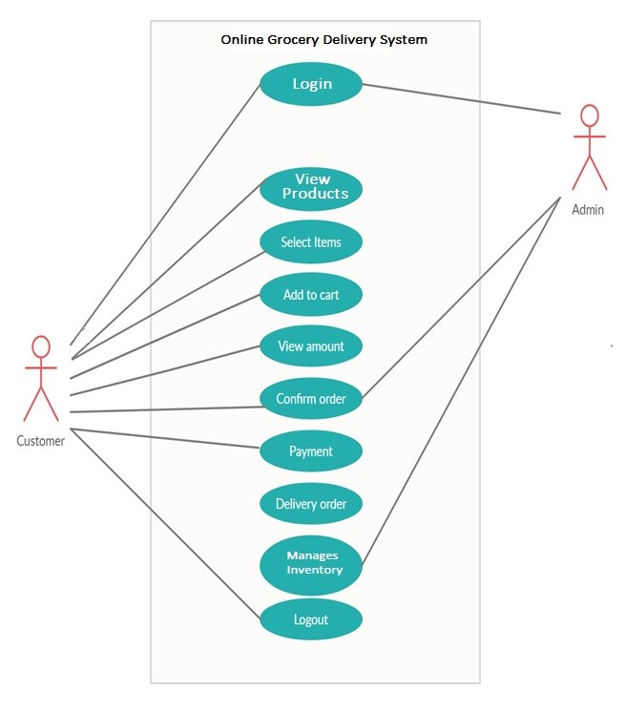

### 5.2 ER Diagram

